Personal, Social and Emotional Development  -Shows empathy and concern for people who are  special to them by partially matching others’  feelings with their own, e.g. may offer a child a toy  they know they like  - Is beginning to be able to cooperate in favourable  situations, such as with familiar people and  environments and when free from anxiety.  - Knows their own name, their preferences and  interests and is becoming aware of their unique  abilities- Is developing an understanding of and interest in  differences of gender, ethnicity and ability  -Shows a sense of autonomy through asserting  their ideas and preferences and making choices  and decisions  Religious Education from Come and See Curriculum  Eucharist  Growing  Life to the full curriculum RSE | Physical Development  -Climbs up and down stairs by placing both feet on  each step while holding a handrail for support  -Uses wheeled toys with increasing skill such as  pedalling, balancing, holding handlebars and sitting  astride  -May be beginning to show preference for  dominant hand and/or leg/foot  -Turns pages in a book, sometimes several at once  -Can hold a cup with two hands and drink well  without spilling  -Develops some independence in self-care  and shows an awareness of routines such as  handwashing or teeth cleaning but still often  needs adult support  -Develops increasing understanding of and control  of the bowel and bladder urges and starts to  communicate their need for the preferred choice  of potty or toilet | Communication and Language Development  -Shows interest in play with sounds, songs and  rhymes  -Single channelled attention; can shift to a different  task if attention fully obtained – using child’s name  helps focus  -Understands who, what, where in simple questions  (e.g. Who’s that? Who can? What’s that? Where is?)  -Developing understanding of simple concepts (e.g.  fast/slow, good/bad)  -Learns new words very rapidly and is able to use  them in communicating  -Uses a variety of questions (e.g. what, where, who)  -Uses longer sentences (e.g. Mummy gonna work)  -Beginning to use word endings (e.g. going, cats)
Key sessions  -Food from around the world  -Where does food come from  -Cooking and baking skills  -Healthy Living  -Healthy choices  -growing our own food  Cooking and Baking: Pizzas, Beans on Toast, Honey Biscuits, Fruit Salad, Vegetable printing, Cupcakes for mothers day BF and Decorating biscuits | 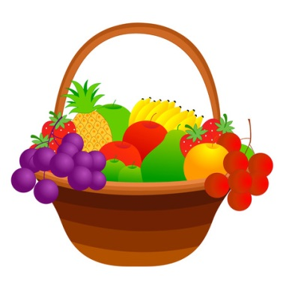  Yummy Yummy in my Tummy | Key Texts  Beans on Toast  Hot Potato  Handa’s surprise  Honey Biscuits  Oliver’s Vegetables  Mr Wolfs Pancakes  Ice Cream Cones for Sale  Kitchen Disco
Mathematics  Spatial Awareness  - Moves their bodies and toys around objects and  explores fitting into spaces  - Begins to remember their way around familiar  environments  - Responds to some spatial and positional language  - Explores how things look from different  viewpoints including things that are near or far  away  Shape  - Chooses puzzle pieces and tries to fit them in  - Recognises that two objects have the same shape  - Makes simple constructions |  | Literacy  Phonics sessions- see separate planning  -Fills in the missing word or phrase in a known  rhyme, story or game, e.g. Humpty Dumpty sat on a  -Begins to recognise familiar logos from children’s  popular culture, commercial print or icons for apps  -Enjoys rhythmic and musical activity with  percussion instruments, actions, rhymes and  songs, clapping along with the beat and joining in  with words of familiar songs and nursery rhymes  -Makes up stories, play scenarios, and drawings in  response to experiences, such as outings  -Sometimes gives meaning to their drawings and  paintings
Expressive Arts and Design  - Experiments with ways to enclose a space, create  shapes and represent actions, sounds and objects  -Enjoys and responds to playing with colour in a  variety of ways, for example combining colours  -Uses 3D and 2D structures to explore materials  and/or to express ideas  -Uses movement and sounds to express  experiences, expertise, ideas and feelings  -Experiments and creates movement in response to  music, stories and ideas  Topic Coverage: Materials, Drawing:Lines and shapes | Events/ Visitors/ Visits  -Stay and Play morning session 2  -Mothers Day Tea  -World Book Day  -Laing art gallery  -Easter Celebrations  -St Marks Day-Ice cream  -Easter Celebrations: Cards/ Easter Egg Hunt, Easter Egg Competition , Easter Service | Understanding the World  - Shows interest in the lives of people who are  familiar to them  -Enjoys joining in with family customs and routines  -Comments and asks questions about aspects of  their familiar world such as the place where they  live or the natural world  -Shows care and concern for living things and the  environment  - Begin to understand the effect their behaviour can  have on the environment  Topic Coverage: Season:Spring,

