Personal, Social and Emotional Development  -Peer massage  -Collective Worship  -Bible Story: Noah’s Ark  -Values Education weekly  -Friendship Recipe activity  -Kindness post cards  -Super Me superheroes  Religious Education from Come and See  Birthdays  Christmas and Advent  Life to the full curriculum: RSE | Physical Development  Fine Motor  Fork Painting  Toothbrush painting  Dough disco  Squiggle while you wiggle  Marble and golf tees  Tweezers  Hole punches and paper  Threading and weaving  Nuts and bolts  Magnets and coins  Pegs and cotton wool  Pipe cleaners and holes  Sticker Names  Scissors  Gross Motor  Go Noodle  Baby Yoga  Obstacle course  Astro Turf football  Basket ball  Balancing act  Bats and Balls  Snowy Feet | Communication and Language Development  -Remembrance Day: Discussion and Poppy field pictures  -Bonfire Night: Discussion and firework pictures  -Talk Boost Sessions  -Old McDonald had a farm: Farm animals  -Rumble in the Jungle: Jungle animals  -Commotion in the Ocean: Under the sea animals  -Mouse’s new home: Forest animals  -Babies in the Snow: Arctic animals  -Six Dinner Sid: Pets and how to care for them  -Dear Zoo: Endangered animals  -Alice the Camel has 5 humps: desert animals  -Snow Play: scooping, melting, icy, measuring, exploring
Cooking and Baking: Mince Pies, apple crumble, toffee apples  Famous Artist: Eric Carle  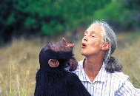  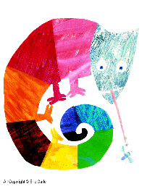  Famous Scientist: David Attenborough, Jane Goodall | 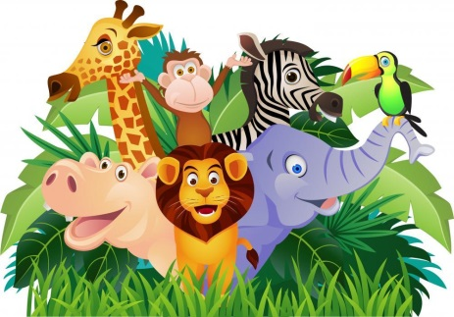  A Carnival of Animals | Key Texts  Strange Creature  Rumble in The Jungle  Commotion in the Ocean  Old McDonald had a farm  Noah’s Ark  Dear Zoo  Night Monkey, Day Monkey  The Three little pigs  Handa’s Hen  The Tiger who came to Tea  Brown Bear  Slowly slowly  Polar Bear Polar Bear  Six Dinner Sid  A range of Christmas and Advent stories
Mathematics  -Recognising Numbers 0-10  -Ordering Numbers 0-10  -Rote counting forwards and backwards  -Counting with 1:1 correspondence  -Number rhymes and songs: 10 little monkeys jumping on a bed, 5 little speckled frogs  -Patterns in daily routines: what comes first, what comes next, daily timetables  -Pattern in brushing teeth routine  -Colour Patterns  -Adding more objects to a group  -Taking objects from a group  -Size: biggest to smallest, tallest to shortest  -Time: exploring clocks and numbers  -Positional Language using farm role-play  -How many? Using our fingers to count |  | Literacy  Phonics sessions begin- see separate planning  Talk for writing- Handa’s Hen  Talk for writing- Brown Bear Brown Bear  Talk for writing- Polar Bear Polar Bear  Talk for writing- The Three Little Pigs  Rainbow letters- The letters in our names  Strange Creature- exploring animal body parts (tails, horns, humps, manes etc)  Night Monkey, Day Monkey- exploring nocturnal animals  -Name Recognition and name hunts  -Name Writing  -Rhyme Books  -Story Sack Fun  -Mark Making Books  -Mark making in glitter
Expressive Arts and Design  -Junk Modelling Habitats  -Mixing Primary colours  -Colour names  -Finger printing sheep  -Fluffy ducklings  -Paper plate tigers  -Painted Pelican Beaks  -Spiky hedgehogs  -Pom Pom polar bear printing  -Rainbow fish  -Christmas Cards and Calendars  -Christmas arts and crafts | Events/ Visitors/ Visits  -Show and Tell begins  -Trip to Chopwell Woods  -Parents Evening: settling in chat  -Stay and Play 1 parent morning  -Nativity Performance and rehearsals  -Travelling Cribs  -Remembrance Day  -Diwali  -Bonfire Night  -Christmas Celebrations: party, gifts, cards, calendars, fayre, lunch, disco, jumper day, pantomime  -Farm in a Box  -ShoeBox Appeal  -Talk Boost final meeting and certificates celebration  -Creativity Week  -Phonics Café | Understanding the World  -Animal Habitats: what does a farm look like and who lives there? What does a jungle look like and who lives there?  -Animal Bodies: Tails, humps, horns, scales, fur, paws, snouts, claws etc  -Endangered animals: how can we help?  -Animal Babies: cubs, ducklings, chicks, kittens, puppys etc  -Winter: What happens to the weather? Snow? Ice? Cold, where do the animals go? Change for plants and trees, what clothes do we need to wear.
Vocabulary  Animal Habitats: farm, jungle, arctic, zoo, desert, ocean  Endangered Animals  Environment  Pets- cats, dogs, rabbits, amphibians, hamsters  Animal Body Parts: tails, humps, snouts  Animal Baby names: cubs, kittens, puppys, piglets, ducklings, chicks  Animal Names: lions, tigers, monkeys, camels, flamingos, giraffe  Winter: snow, ice, frozen, cold, hibernation, migration, sleeping, frosty, freezing  Size language: big, small, tiny, huge, tall, short  Positional language: behind, in front, under, on top, in between, next too, inside, outside | Key Questions  Which animals have tails? Do animals have fingers? I wonder how a monkey hangs from the trees? I wonder how a giraffe reaches it’s food? I wonder why a flamingo stands on one leg? I wonder what a Tiger likes to eat?  How can we care for our pets? What does a pet need?  What is an endangered animal? How can we help? What does extinct mean?  Which one is the biggest? Which one is the smallest? How do you know?  What happens when we put the water in the fridge? What happens when we pour water onto the snow? | Characteristics of Effective Learning  Finding out and exploring-  -Showing curiosity  -Using senses to explore the world  -Engaging in open ended activities  -Particular interests  Being Involved and Concentrating-  -Maintain focus  -High levels of energy in activity  -Not easily distracted  -Pays attention  Having their own ideas-  -Thinking of ideas  -Solving problems  -Discovering new ways to do things.

